Kitman Yiu CIT185753

Teacher: Donald Couts

A lightweight Quality Mangagment Process for a game

(Application Testing & Metrics)

Assignment 4

Due Date: 8/6/2015

Table of Content

Introduction 3

Definition OF Light weight quality management system(LWQMS) 3

Range of LWQMS 3

Pupouse of LWQMS 3

Controls for external entities 4

Team members 4

Orgnination 4

Quality Pocily 5

adopted Standards 5

Records and reports 5

Quality Planning 5

Quality Control 7

Records collection, maintenance, and archiving 7

Quality Ensure 7

Quality Improvement 7

ToolS, techniques, methods 7

Quality Planning 7

Quality Control 7

Quality Ensure 7

Quality Improvement 7

Training required 7

Quality Planning 7

Quality Control 8

Quality Ensure 8

Quality Improvement 8

Risk management 8

Quality Planning 8

Quality Control 8

Quality Ensure 8

Quality Improvement 8

QA metrics 8

Quality Planning 8

Quality Control 8

Quality Ensure 8

Quality Improvement 8

Quality problem reporting and corrective action 9

Quality Planning 9

Quality Control 9

Quality Ensure 9

Quality Improvement 9

Reviews and AUDITS (审核与审查) 9

Quality Planning 9

Quality Control 9

Quality Ensure 9

Quality Improvement 9

Reference 11

# Introduction

## Definition OF Light weight quality management SYSTEM (LWQMS)

To able to create a light weight quality management system, we first have to define the following keywords:

**Light weight:** relatively simpler or faster or that has fewer parts than something else.(ref) (As ISO is international, standardized QMS, this will be used as a benchmark for this game. The documentation created for this game will be lightweight in comparison to the ISO standard QMS.)

**Quality:** A [measure](http://www.businessdictionary.com/definition/measure.html) of excellence or a state of being [free](http://www.businessdictionary.com/definition/free.html) from [defects](http://www.businessdictionary.com/definition/defect.html), [deficiencies](http://www.businessdictionary.com/definition/deficiency.html) and

[significant](http://www.businessdictionary.com/definition/significant.html) [variations](http://www.businessdictionary.com/definition/variation.html).  
  
Read more: <http://www.businessdictionary.com/definition/quality.html#ixzz3bFzZhMtf>

**Management System**: describes the set of procedures an organization needs to follow in order to meet its objectives.

In some small organizations, there may not be an official system, just "our way of doing things” that is mostly kept in the heads of the staff.

But the larger the organization, the more likely that procedures need to be recorded to ensure everyone is clear on who does what. This process of systemizing how things are done is known as a management system.(ref)

Thus, the definition of a Light weight quality management system will be defined as a simplified system of procedures to manage quality, especially in terms of a game being free from defects or bugs, as benchmarked against the more complex and in-depth ISO Quality Management System. In another words, it means a set of rules to ensure that the game reaches a state free from significant defects and deficiencies.

For the purpose of this document the term Quality Management Process is equal the term Quality Management System.

## Range of LWQMS

Since lack of information of about the QMS range. In game environment I will define the LWQMS will determining which standards or documentation will be applied not only ensure the quality of the game and also ensure that the game environment can be setup to reach the quality of the game. However, the procedure to reach these benchmarks of quality and what are the exactlcy data will be found in separate documents, such as the Test Plan, the Technical Design Document, the Game Design Document, etc.

## Pupouse of LWQMS

The purpose of this Light weight quality management system is to ensure to following meet the desired level of quality:

* Quality of Story
* Quality of the game mechanics
* Game audio
* Download and upload experience
* Visual style effects such as GUI
* Reliability
* Efficiency
* Integrity
* Usability
* Maintainability
* Testability
* Flexibility
* Portability
* Reusability
* Interoperability
* Security
* Safety
* Design
* Developer
* Purchasing Control
* Production Control
* Customer feedback

## Controls for external entities

# Team members

4 team members

* 2 Programmer
* 2 Artist

# Quality Pocily

本公司质量方针的特性包括﹕

新会厂在下列情况下需进行质量策划﹕

1. 初建质量管理体系﹔
2. 改进现有质量管理体系﹔
3. 公司内部环境发生变化﹐如﹕质量方针修订等﹔
4. 公司外部条件发生变化﹐如﹕法律法规修订后提出了新要求﹐市场情况发生重大变化。

5.4.2.2 质量策划的内容应包括﹕

1. 依据质量方针﹐制定相应的质量目标﹔
2. 识别为实现质量目标所需的质量管理体系的过程﹔
3. 确定为实现质量目标所需要的资源﹔
4. 定期评审﹐确保持续改进。
5. 质量策划的输出所形成的文件(如质量手册﹑质量程序或质量计划等 )应当始终保持与公司的质量目标相适应﹐当公司对现存的质量管理体系进行更改或公司其它状况发生变化时﹐对这些文件要做相应的更改﹐以确保整个体系的完整性。
6. 5.4.2.4 编制质量计划是质量策划的一部份﹐质量计划是质量策划的结果之一。
7. 相关文件﹕质量目标实施情况检查表﹑质量计划

# adopted Standards

Oso9000

Gap Analysis Checklist

Quality Policy

Quality Manual

 Procedures

Work Instructions

Records

8 principles

<http://www.abtrex.com/wp-content/uploads/2009/12/Abtrex-QMSHierarchy.gif>

<http://usercontent2.hubimg.com/3796577_f1024.jpg>

Coding standard

UI standard

# Orgnination

### Project Lead/ Manager:

* Establishing the quality policy
* Ensuring quality objectives
* Establish ﹑ implement and maintain a quality management system
* Responsible to tell all staff the importance of consistent output quality concept
* Awareness and compliance with laws and regulations of sale
* Setting quality objectives
* Conducting management reviews
* Ensuring access to the resources needed
* Approve all salary employee hiring or dismissal
* Approval of the company's quality manual
* Approved budget expenditures within operating limits
* Approved main suppliers and outsourcing providers
* Responsible for developing and maintaining a quality manual
* Responsible for establishing and maintaining quality management system implementation
* Performance reporting quality management system and the need for improved
* Internal audits and management reviews

### Programmer Lead

* Maintain and continually improve the daily operations of the Department of Research and Development and Quality Assurance Department
* Address issues related to the quality

### Artist Lead

* Maintain and continually improve the daily operations of the Department of Research and Development and Quality Assurance Department
* Address issues related to the quality

### Designer Lead

* Maintain and continually improve the daily operations of the Department of Research and Development and Quality Assurance Department
* Address issues related to the quality
* Product Development

### Test Lead

* Maintain and continually improve the daily operations of the Department of Research and Development and Quality Assurance Department
* Address issues related to the quality

### Customer Services

* Answering and tracking customer complaints
* When the complaints of customers, in cooperation with relevant departments, to identify the causes and solutions

### ???lead

* To maintain and continue to improve the daily work of the Department of Logistics
* Supervise the performance of the logistics general manager of various departments to achieve management objectives
* Responsible for communication and logistics business-related government departments
* Maintain good communication work with the relevant supplier’s
* Logistics cost control。
* Activities to ensure and monitor the entire production planning department within the norms according to ISO9001
* Training, management and monitoring of production planner

### HR

* Planning and implementation of year-end employee performance review. Ensure proper implementation of the staff salaries and benefits. Provide the right balance of the number of paid holidays, so that employees can more easily arrange holiday.
* Monitoring the probation staff, nearly time to the trial period, the performance review form probationary period, review
* Provide monthly or quarterly for the new employee orientation. Assist in the training of employees. According to description of each sector to provide jobs and develop training programs. And continue to watch the progress of the new training methods.
* Resolve complaints of employees and dispute resolution between employees.
* Contact Quality Management System matters related to external parties.
* As the company's policy or program files of any change, notify the staff.
* Empower guard, refused to former employees or unauthorized visitors to enter the company.
* Authorizing payment of compensation and retention of medical expenses for all employees’ record.

### Responsibilities

|  |  |  |  |  |  |  |  |  |
| --- | --- | --- | --- | --- | --- | --- | --- | --- |
|  | Project Lead | Programmer Lead | Artist Lead | Designer Lead | Test Lead | HR Lead | ??? Lead | ??? Lead |
| Kitman Yiu |  |  |  |  |  |  |  |  |
| Michael Brown |  |  |  |  |  |  |  |  |
| Trent |  |  |  |  |  |  |  |  |
| Locken |  |  |  |  |  |  |  |  |

### Documentation

|  |  |  |  |  |  |
| --- | --- | --- | --- | --- | --- |
|  | GDD | TDD | Project Management Plan | Test Plan | Post Morden |
| Project Lead |  |  |  |  |  |
| Programmer Lead |  |  |  |  |  |
| Artist Lead |  |  |  |  |  |
| Designer Lead |  |  |  |  |  |
| Test Lead |  |  |  |  |  |
| HR Lead |  |  |  |  |  |
| ??? Lead |  |  |  |  |  |
| ??? Lead |  |  |  |  |  |

# Records and reports

## Quality Planning

The following documentation is create to ensure the things from above

* Procedures
* Work Instructions
  + Game Design Document
  + Technical Design Document
  + Project Manager Documents
  + Test Plan Documents
  + Post Modern

A discribeltion is provide below to explain what it use for and how thing will things will it improve

* **Procedures**

An official [document](http://www.businessdictionary.com/definition/document.html) [produced](http://www.businessdictionary.com/definition/produce.html) by a [business](http://www.businessdictionary.com/definition/business.html) that details how its [quality management system](http://www.businessdictionary.com/definition/quality-management-system-QMS.html) [operates](http://www.businessdictionary.com/definition/operate.html)

* **Work instruction**

**QMS Document**

**This is the current QMS document.** This documentation determining which standards or documentation will be applied not only ensure the quality of the game and also ensure that the game environment can be setup to reach the quality of the game. However, the procedure to reach these benchmarks of quality will not be in this documentation.

* **Technical Design Documentation(TDD)**

The technical Design Document will be mainly create and used by programmer.

The goal of this documentation is tell the programmer how to create this game.

The document is too improve the following points from above.

* + Quality of Story
  + Quality of Game Mechanics
  + Quality of Audio
  + Quality of Visual Effect
  + Reliability
  + Usability
  + Flexibility
* **Game Design Documentation(GDD)**

The Game Design Document will be mainly create by Designers and Artist.

The goal of this documentation is too present the game idea and what element are in the game.

* The document is to improve the follow points:
  + Quality if Game Mechanics
  + Reliability
  + Efficiency
  + Integrity
  + Usability
  + Maintainability
  + Testability
  + Flexibility
  + Reusability
  + Interoperability
  + Security
  + Safety
* **Project Management Plan**

This document will be create by the team leader or project manager.

The goal of this documentation is too create a plan which you can manage your project.

The document will be able to improve the following points:

* **Marketing plan**

This document will management by the marketing team or the team leader in small organization.

The goal of this document is too create a plan which can increase the sales of your game.

The marketing plan will be able to improve or increase the following points:

* **Test Plan Document**

This document will create by the test team or team leader.

The purpose of this document will what items needed to be test and how the items can be tested.

The Test plan documents will able to improve or increase the following points:

* **POST MOEDREM:**

This documentation will be written by the project lead or team leader.

The goal of this document is too do revision and see what went wrong and provide a suation or either what thing are good that we should keep for the next project.

The post modern will be able to improve the following points:

A standard template will be provide for the documentations

## Quality Control

### Records collection, maintenance, and archiving

As least three records backup and final project will be project lead, this will improve the following points

To allow the documentation reaches the following condition:

The naming for filename will be provide below: xxxDoc_V (version), example GDDDoc_V1 , this will improve the following point.

## Quality Ensure

To ensure the documentation reaches the standard

There will be a checklist for the project manager to check

All team member must be able to understand the documentation

## Quality Improvement

The following lifecycle will be apply to the documentation

# ToolS, techniques, methods

## Quality Planning

The using the following software it will improve the following points

* Reliability
* Efficiency
* Integrity
* Usability
* Maintainability
* Testability
* Flexibility
* Portability
* Reusability
* Interoperability
* Security
* Safety
* Design
* Developer
* Purchasing Control
* Production Control
* Customer feedback

The following tools can be consider while developing the project

|  |  |  |  |
| --- | --- | --- | --- |
| Name | Type of Tool | Description | Link |
| Teamwork Project | Team Management Tool | Price : 10/per month AUD  Pros :   * Easy to use * Stable * Cheap   Cons :   * Still waiting them to develop charts to able to visualize the result more easily | <https://www.teamwork.com/projects> |
| ProWorkFlow | Team Management Tool | Price : 10/per month AUD (one user only)  Pros :   * Easy to use * Stable * Cheap   Cons :   * The Gantt does not show depencpeny |  |
| Teamwork Desk | cloud-based customer support software | Price: Free 150 Tickets every month. After $0.05 per-ticket  Pros :   * Easy to use * Stable * Cheap   Cons :   * Not now | <https://www.teamwork.com/desk> |
| Intelex | QMS Tool | Price: Unknown  Pros :   * Easy to use. * Stable. * Have Trial version to test. * Follow ISO9001 Standard   Cons :   * Not now | <http://www.intelex.com/landing/Intelex_Quality_Management_System-300campaign.aspx?source=h%2b1cla%2byaKH2gBG7oq333hx90y0Zs0roSd50rCzALwaaTS4x9gyVILMtWyOgGyzOEA5bayvsz%2frML8PB%2fHlccA%3d%3d&gclid=CjwKEAjw-ZqrBRDt_KjhjcbzhhISJAAlRGvlBXvW0RSxpgIoS146i52xwcYqC0g2PtHccuW-me0-JBoCt2jw_wcB> |
| Quality Assurance Evaluation | QMS Tools | Price: $299 for One (Annual Fee)  $499 for two (Annual Fee)  $999 for two (Annual Fee)  Pros :   * Easy to use. * Stable. * Have Trial version to test.   Cons :   * Not now   More Information:http://www.maus.com.au/free-trial-software-product-samples-brochures-video-demonstrations/ | <http://www.maus.com.au/product/maus-quality-hub/?gclid=CjwKEAjw-ZqrBRDt_KjhjcbzhhISJAAlRGvl40lGcaXZ6MyLFRJZyvxOIBIPHPcBuziL-xqGHi_yBBoC1P7w_wcB> |
| Skype | Communication software | Free  providing [video chat](http://en.wikipedia.org/wiki/Videotelephony) and voice calls from computers, tablets, and mobile devices via the Internet to other devices or telephones/smartphones  MUST BE USED AND INSTALL IN EVERY COMPUTER | <http://www.skype.com/en/> |
| Team viewer | Communication software | Free  is a software proprietary [computer software](http://en.wikipedia.org/wiki/Computer_software) package for [remote control](http://en.wikipedia.org/wiki/Remote_control_(computing)), [desktop sharing](http://en.wikipedia.org/wiki/Desktop_sharing), online meetings, [web conferencing](http://en.wikipedia.org/wiki/Web_conferencing) and [file transfer](http://en.wikipedia.org/wiki/File_transfer) between computers.  MUST BE USED AND INSTALL IN EVERY COMPUTER | <https://www.teamviewer.com> |
| XMind | Mind map tool | Free  A Software supports [mind maps](http://en.wikipedia.org/wiki/Mind_maps), [fishbone diagrams](http://en.wikipedia.org/wiki/Fishbone_diagram), [tree diagrams](http://en.wikipedia.org/wiki/Network_topology#Tree), [organization charts](http://en.wikipedia.org/wiki/Organization_chart), spreadsheets, etc. Normally. it is used for knowledge management, meeting minutes, task management, and [GTD](http://en.wikipedia.org/wiki/Getting_Things_Done). Meanwhile, XMind can read [FreeMind](http://en.wikipedia.org/wiki/FreeMind) and [MindManager](http://en.wikipedia.org/wiki/MindManager) files, and save to [Evernote](http://en.wikipedia.org/wiki/Evernote)  MUST BE USED AND INSTALL FOR EVERY PROGRAMMER IN THE TEAM | <http://www.xmind.net/download/win/> |
| Google Chrome |  | freeware web browser developed by **Google**  MUST BE USED AND INSTALL FOR EVERY PROGRAMMER IN THE TEAM | <http://www.google.com/chrome/> |

b) 顾客投诉的处理﹔

## Quality Control

N/A

## Quality Ensure

The make sure the software is reliable to use and easy to use the following metrics can be applied to test:

Number of customer that is using the software

The satfiaction of other customer

A 1- 10 easy and hard thing, and let teammember to test out how easy to use

## Quality Improvement

Project manager will be look up new software that exists on the web, if there are new software and it is easy to use. Use it in next project.

# Training required

## Quality Planning

The following training we be applied to the employee

### Software Training

|  |  |  |  |  |  |  |  |  |
| --- | --- | --- | --- | --- | --- | --- | --- | --- |
|  | Teamwork Project | Teamwork Desk | Intelex | Quality Assurance Evaluation | Skype | Team viewer | XMind | Google Chrome |
| Project Lead |  |  |  |  |  |  |  |  |
| Programmer Lead |  |  |  |  |  |  |  |  |
| Artist Lead |  |  |  |  |  |  |  |  |
| Designer Lead |  |  |  |  |  |  |  |  |
| Test Lead |  |  |  |  |  |  |  |  |
| HR Lead |  |  |  |  |  |  |  |  |
|  |  |  |  |  |  |  |  |  |
|  |  |  |  |  |  |  |  |  |
| Artists |  |  |  |  |  |  |  |  |
| Programmers |  |  |  |  |  |  |  |  |
| Designers |  |  |  |  |  |  |  |  |
| Others |  |  |  |  |  |  |  |  |

### Customer Server Training

The will apply to the HR department

|  |  |  |  |
| --- | --- | --- | --- |
| **Name** | **Price** | **Company Background** | **Website:** |
| Select Training | Unknown | Select Training proudly offers flexible tailored Sales and Customer Service Training courses to Australian and International Businesses. Based in Sydney we cater to all Business management courses and the training needs of your employees. We develop our Professional training courses by getting to know you, your Business, the needs of your customers and team. | <http://www.selecttraining.com.au/customer_service_training?gclid=CjwKEAjw-ZqrBRDt_KjhjcbzhhISJAAlRGvlNffg4xYX8g2TSILRZ8kloVqgui6oAXmuXJkuHBsafxoCI5vw_wcB> |
| Open Training | Unknown | [Similar to TAFE](https://www.opentraining.edu.au/similar-to-TAFE), we offer nationally accredited online diplomas and certificates that are recognised by Australian employers, registered training organisations and Australian universities. | <https://www.opentraining.edu.au/courses/customer-sales-service?mkwid=sYuykov7j&pdv=c&pcrid=62823419786&pkw=customer%20service%20training&pmt=e&gclid=CjwKEAjw-ZqrBRDt_KjhjcbzhhISJAAlRGvllqBGpRcFg8qk2Zot4HiDfmkN-S7DAiYdWCRU51thuxoCH8Pw_wcB> |

## Quality Control

N/A

## Quality Ensure

The ensure the employees now how to use the software, a test with checklist will be run to determine how good they understand the software

) 于培训后﹐以员工评价表评估所提供的培训有效性﹔

d) 每年为所有员工进行表现评审﹐以确保员工认识到他们所从事活动的关联性和重要性﹐以及提升他们对于质量目标的实现的意识; see more at … secetion.

e) 由人力资源及行政部负责保存有关教育﹑培训﹑技能和经历的记录。

## Quality Improvement

The ensure employees know how to use video or Youtube channel tutorial will be provided or join course

# Risk management

## Quality Planning

The risk will be put in project management document

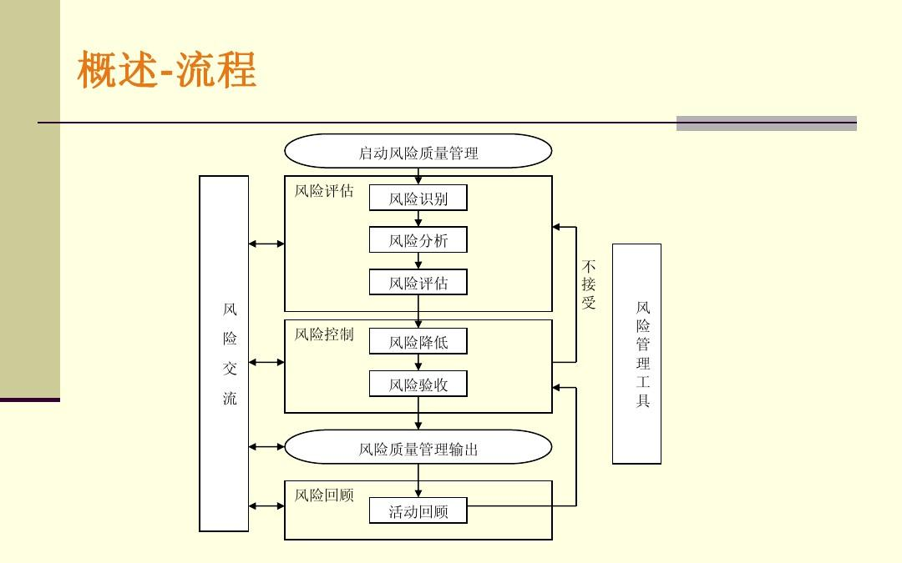

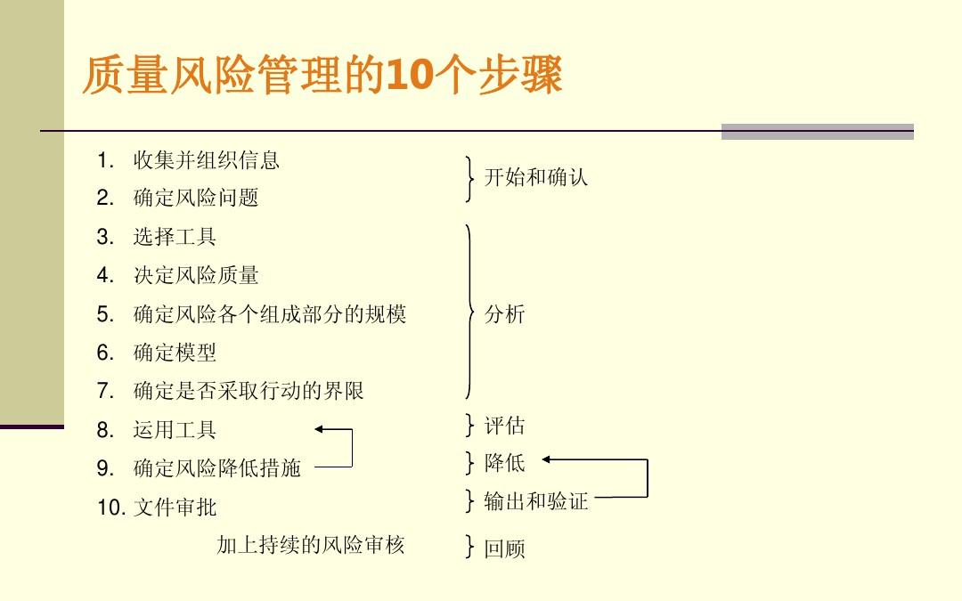

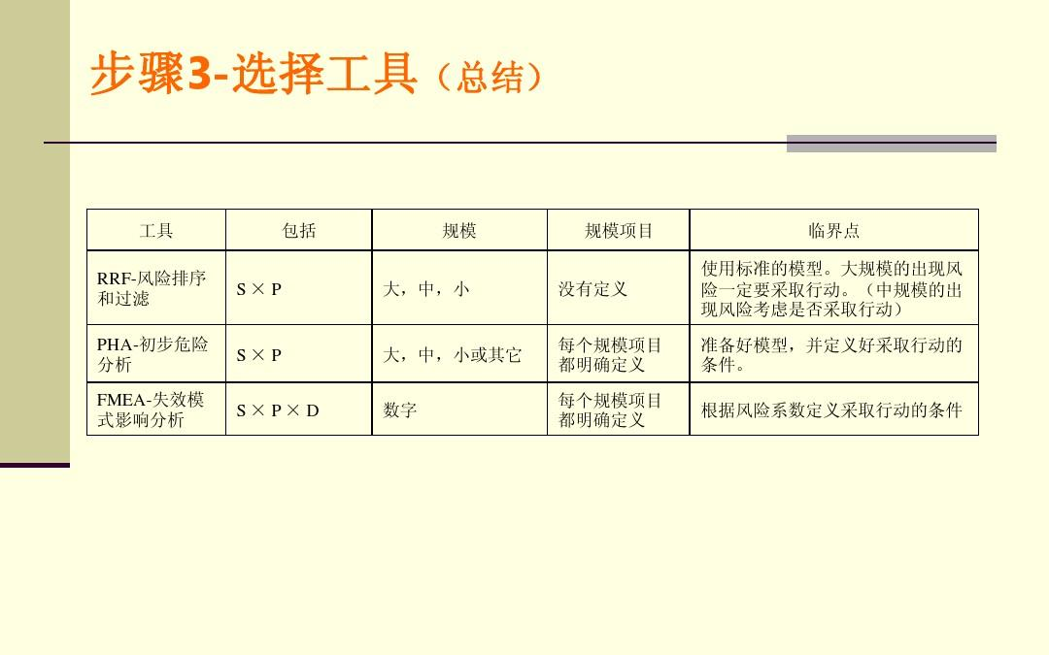

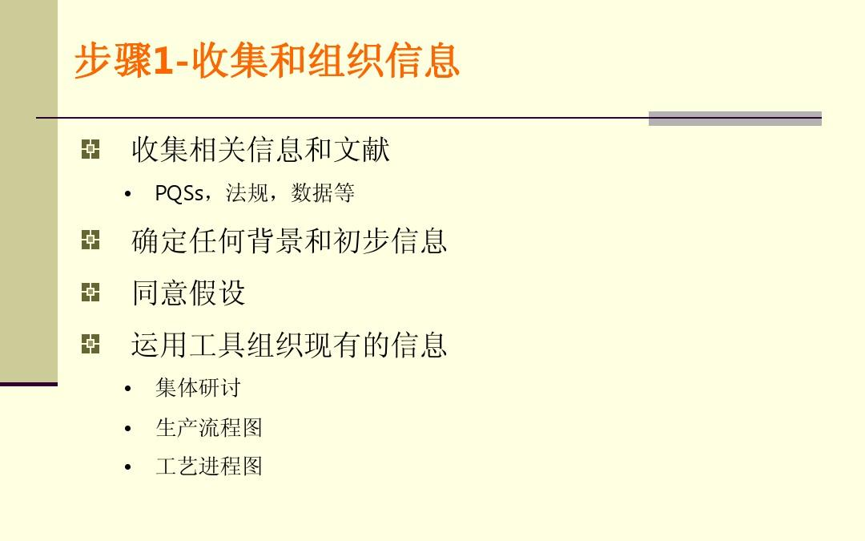

## Quality Control

To able to minizle the risk

## Quality Ensure

To ensure the risk is gone

## Quality Improvement

To keep able to minizle the risk

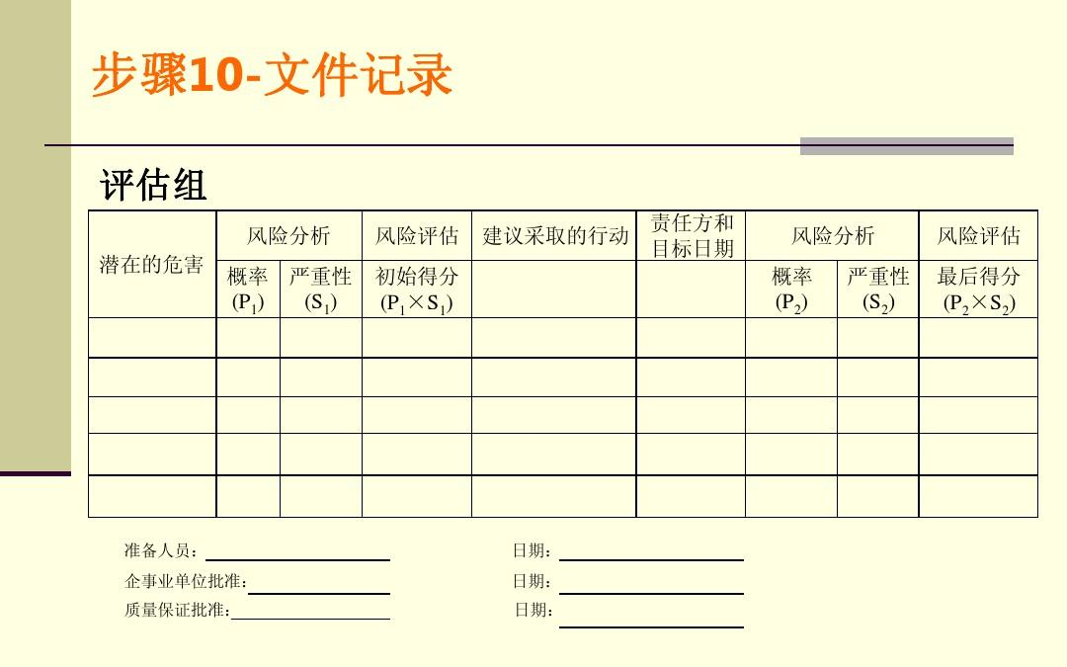

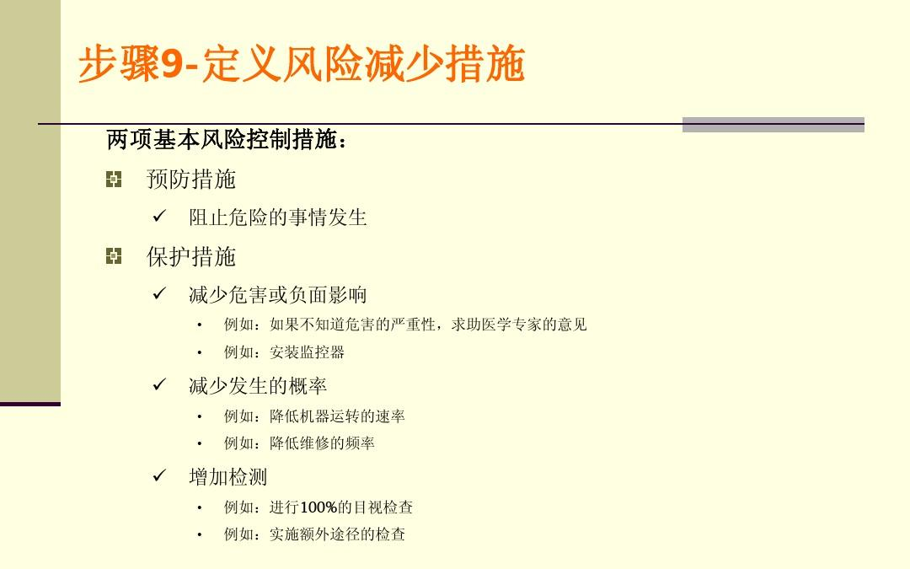

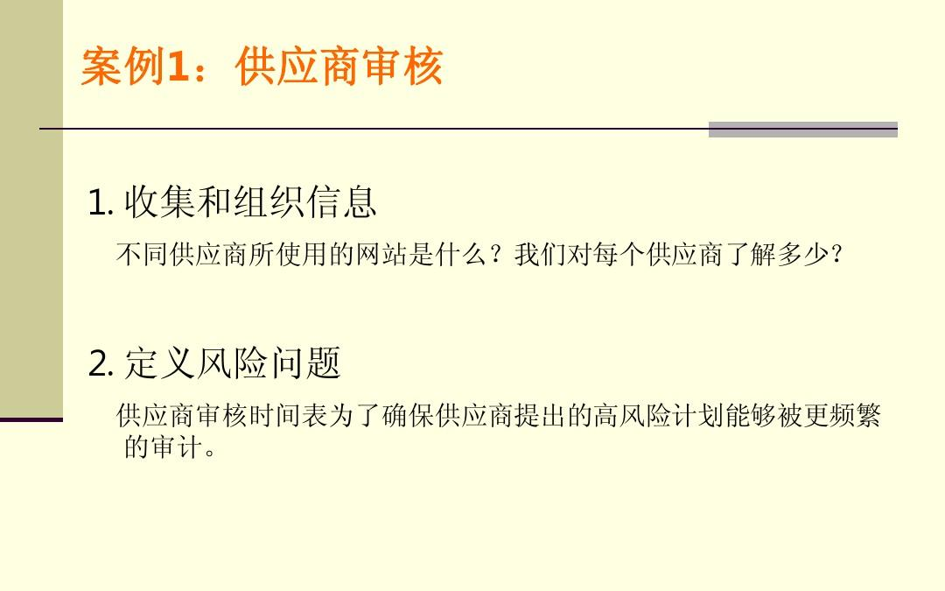

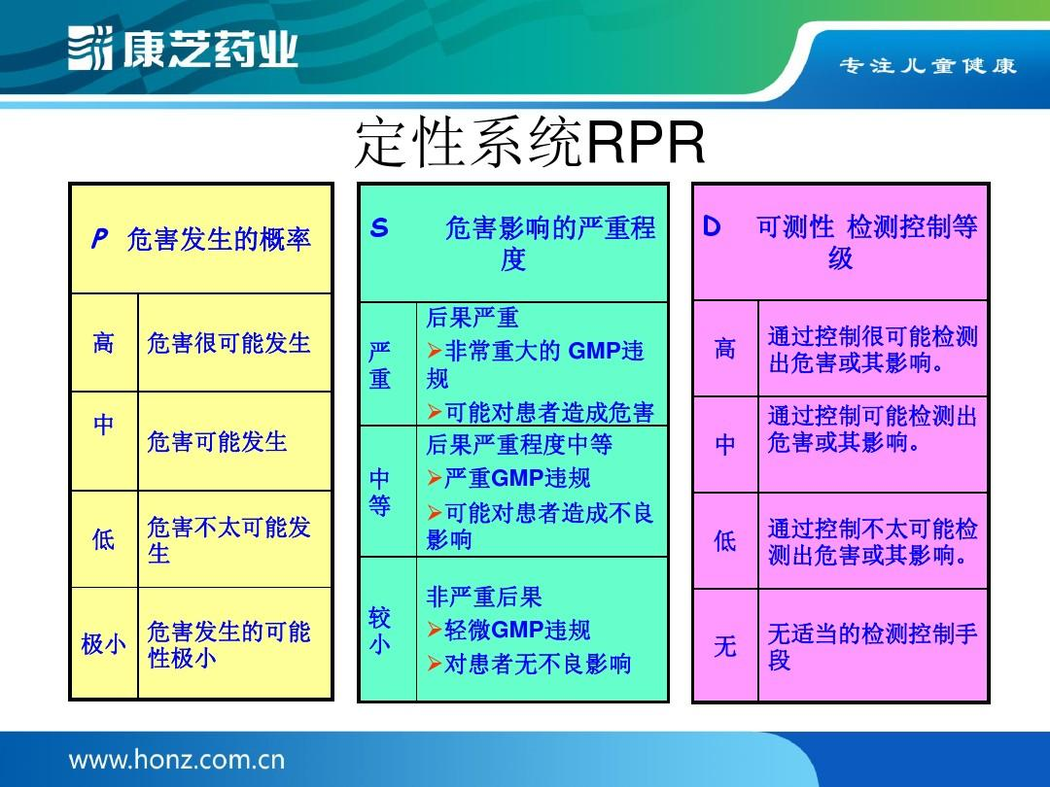

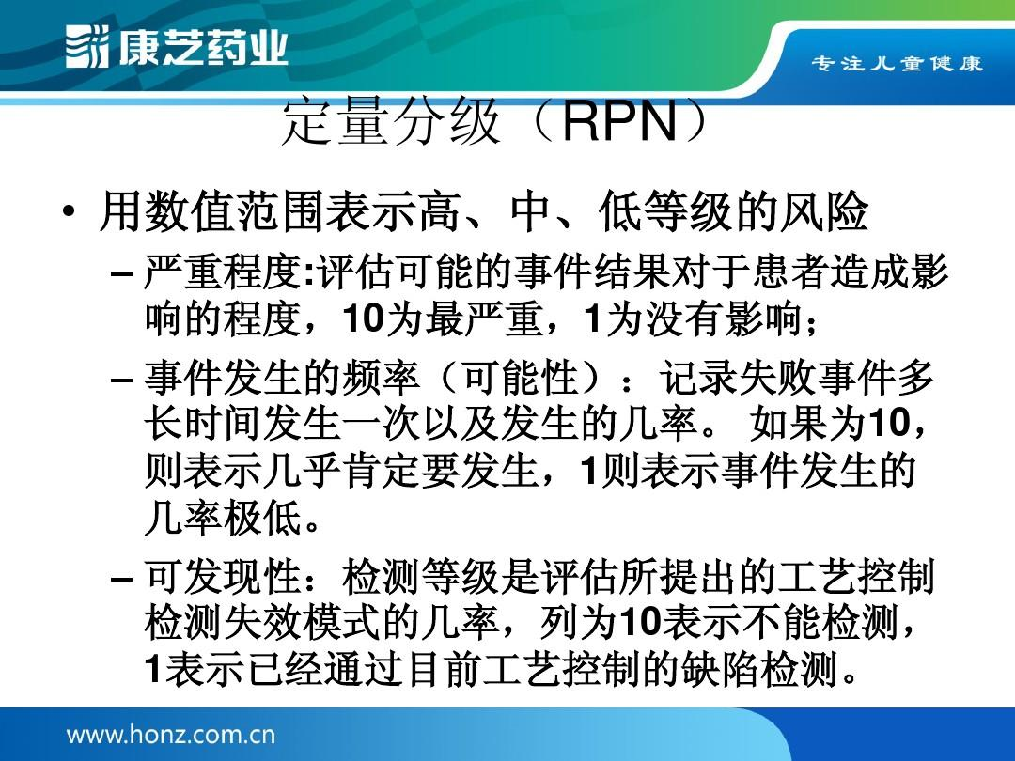

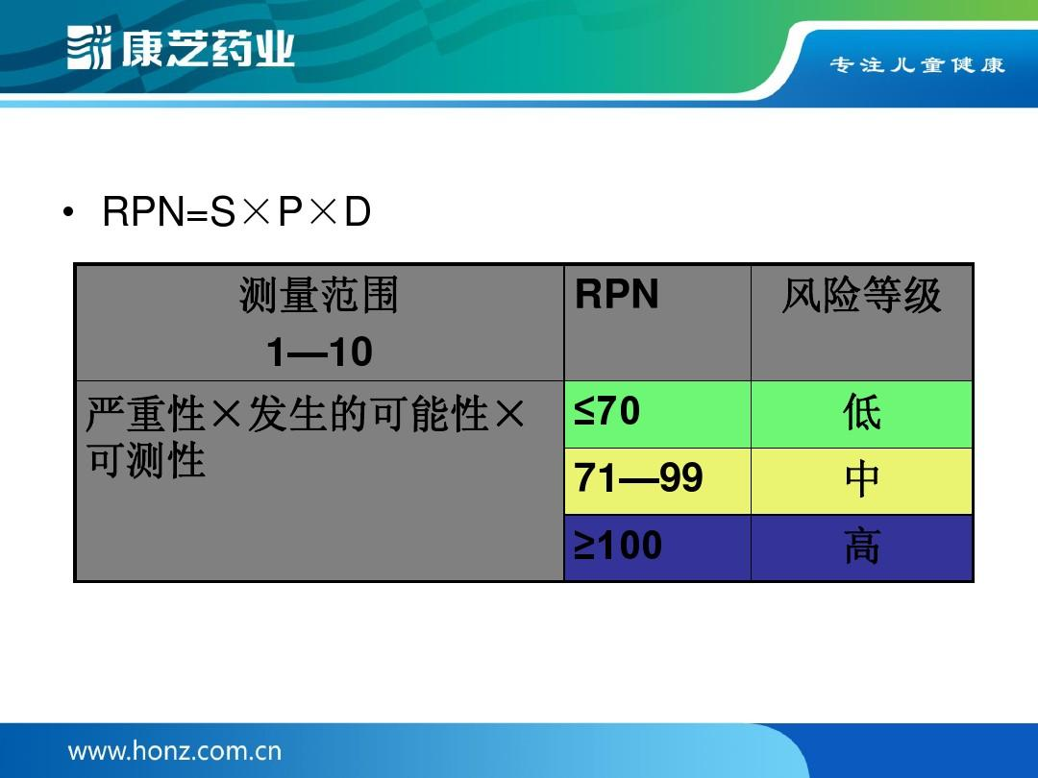

# QA metrics

## Quality Planning

b) 顾客投诉的处理﹔

to able to test the story in GDD

## Quality Control

Control not too much or too little

## Quality Ensure

n/a

## Quality Improvement

Can be added base on the following condition

# Quality problem reporting and corrective action

## Quality Planning

Feedback about quality problem can be reported by customer or staff

For staff

For customer

5 Principles for Problem Solving

b) 顾客投诉的处理﹔

The following diagram shows how to handle customer problrems

## Quality Control

## Quality Ensure

Reperted the customer required

a) 产品信息；

b) 问询﹑合同或订单处理﹐包括对其的修改；

c) 顾客反馈﹐包括顾客投诉。

相关文件﹕生产计划程序﹑顾客投诉程序

## Quality Improvement

# Reviews and AUDITS (审核与审查)

## Quality Planning

b) 顾客投诉的处理﹔

## Quality Controluality Ensure

## Quality Improvement

顾客满意度调查﹔

**6.3 设施**

**7.2.3 顾客沟通 what information need from customer to improve the**

新会厂为使供求双方的沟通能有效地进行﹐特别由生产计划部﹑R&D﹑QA部负责与顾客沟通﹐其内容包括：

The following template is to ensure that the game design document reaches the things above:

To able to report problem the ?? team we create a website , in every computer they will need to make a link on destop , so as following image:

The user have two types of doc one is about the SDLC and the is about the system, the format is showed below

ID

Type of QA problem

Description (need to be SMART)

Priority

Corrective Actions

The steps if feedback from customer

Reply email as following format

# Reference

<http://the9000store.com/what-is-iso-9001-quality-management-system.aspx>

<http://whatis.techtarget.com/definition/lightweight>

<http://www.wendangwang.com/doc/4442ef182dcbcb07d897e531/13>

http://www.wendangwang.com/doc/9e68b5a4e6d2859d13d916a7/12